**EUMedRail Annual Steering Committee held in Brussels**

**12Nov**2019

The Annual Steering Committee of the EUMedRail project was held in Brussels on 6 November 2019. Hosted by the Directorate for Mobility of the European Commission, the meeting was opened by Mr Peter Mihm, EUMedRail project manager, by Mr Talander Jansen on behalf of DG NEAR, Mr Bertrand Collignon from DG Move and Mr Francesc Carbonell representing the Union for the Mediterranean.

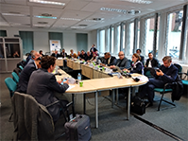

The Steering Committee took place prior to the celebration of the UfM Working Groups (WGs) on Land, Air and Maritime Transport & Logistics, held on 7th and 8th November 2019 in Brussels. In the meeting, the evaluation of the implementation of Action 12 of the Regional Transport Action Plan was discussed and countries complemented the information on the reforms implemented at national level to improve railway safety and interoperability.

The second session of the Conference discussed the developments in the field of international railway cooperation. The EU Agency for Railways provided information about the dissemination of EU rail safety and interoperability legislation in the framework of the ERA Academy and OTIF presented the Convention concerning International Carriage by Rail, COTIF, including the freight and passengers contracts, dangerous good regulation and technical regulation for the safe exchange of vehicles. UIC presented the international activities organised in the framework of the UIC regional assemblies, Africa and Middle-East, and invited the participants to the 12th International Level Crossing Awareness Day (ILCAD) that will be held on 11 June 2020 in York.

The following day, the UfM Working Groups on Land, Air and Maritime Transport & Logistics convened to discuss the consolidated Evaluation Report of the Regional Transport Action Plan for the Mediterranean Region (RTAP 2014-2020) and EUMedRail countries made comments to the Action 12 on safety and interoperability.

**BACKGROUND**

[**EUMedRail 2019**](https://www.era.europa.eu/file/eumedrail2019_en)

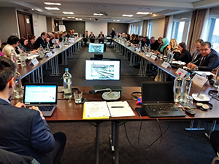

The EUMedRail project, funded by the Directorate-General for Neighbourhood and Enlargement (DG NEAR) of the European Commission, has a budget of 2 million euros for the period between 2017-2021, to carry over technical assistance in neighbour countries: Algeria, Egypt, Israel, Jordan, Lebanon, Libya, Morocco, Palestine and Tunisia. The project supports the implementation of the Actions 9 and 12 of the Regional Transport Action Plan on safety and interoperability.